|  |  |
| --- | --- |
|   **Investigating the Causes of JAMB Failure Rates and Predicting Future Performance Trends (2020–2030)** | **Prepared By**  1. **Chubuikem ChukwuEmeka A (Data Analyst)**  2. **Muhammed Sanni Ahmed (Data Analyst)**  3. **Afadama Ajimego Esther (Data Analyst)**  4. **Theophilus (Data Analyst)**  5. **Helen Mehari (Data Analyst)** |

Contents

1. Research Background 2

2. Objectives 3

2.1 General Objective 3

2.2 Specific Objectives 3

3. Survey Methodology and Design 3

3.1 Steps Taken: 4

3.2 Survey Collected Data Included: 4

4. Tools and Technologies 4

5. Data Analysis (2020-2025) 5

5.1 Descriptive Statistics 5

5.2 Demographic Trends. 5

5.3 Subject-Level Analysis 6

5.4 State-Level & Institutional Insights. 6

5.5 Correlation & Relationships 7

5.6 Predictive Modeling 7

5.7 Dataset Interpretation 7

5.8 Forecast Logic 8

5.9 Projection Model 8

6. Recommendations 9

7. Challenges Encountered 10

8. Conclusion 10

# 1. Research Background

The Joint Admissions and Matriculation Board (JAMB) examination is a critical gateway for students in Nigeria seeking university admission. Over recent years, an increase in failure rates has raised concern among educators, students, and policymakers. This project aims to analyze student performance trends from 2020 to 2025 and predict outcomes through 2030, using data-driven methods.

# 2. Objectives

## 2.1 General Objective

* To comprehensively analyze historical JAMB performance trends (2020-2025), identify key influencing factors, and forecast future outcomes (through 2030) to provide data-driven recommendations for improving student success and addressing educational challenges in Nigeria.

## 2.2 Specific Objectives

* **Data Collection and Preparation:** To design and administer a structured survey to JAMB examinees (2020-2025) and subsequently clean, preprocess, and prepare the collected data for analysis.
* **Performance Trend Analysis:** To conduct an in-depth descriptive statistical analysis of JAMB scores from 2020-2025, examining overall performance, score distribution, and trends over time.
* **Factor Identification and Correlation:** To identify and analyze the relationships between student demographics (gender, age, state), academic background (school type), preparation methods, exam day experiences (CBT familiarity, center conditions), and JAMB performance.
* **Predictive Modeling:** To develop and evaluate a machine learning model (e.g., Random Forest classifier) capable of predicting student JAMB performance tiers (High/Medium/Low scores) or success (admitted/not admitted) based on identified influencing factors.
* **Future Outcome Forecasting:** To forecast JAMB admission success and failure rates from 2026 to 2030 under conservative, moderate, and optimistic scenarios, utilizing historical trends and relevant educational insights.
* **Actionable Recommendation Development:** To derive and present practical, data-backed recommendations for policymakers, educators, and other stakeholders aimed at improving student preparation, enhancing exam infrastructure, and bridging educational disparities in Nigeria.

# 3. Survey Methodology and Design

To understand the underlying causes of JAMB performance, we conducted a structured survey targeting individuals who sat for the exam between 2020 and 2025. The survey was built using Google Forms and distributed via student groups, educational platforms, and email.

## 3.1 Steps Taken:

1. **Data Collection:** Google Form survey exported as CSV.
2. **Data Loading:** Imported into Python using pandas.
3. **Data Cleaning:** Removed invalid entries, standardized column names, and handled missing values.
4. **EDA:** Visualized score trends, demographics vs. performance, and major prep factors.
5. **Modeling:** Built a supervised machine learning classifier (Random Forest).
6. **Forecasting:** Used linear regression to predict success rates (2026–2030).
7. **Recommendations:** Derived actionable insights based on findings.

## 3.2 Survey Collected Data Included:

* Demographics: Gender, Age, State
* Academic background: School type, exam year
* Performance: Highest JAMB score
* Preparation methods and challenges
* CBT familiarity and center conditions
* Exam day experiences and self-rated confidence

Total valid responses after cleaning: **54**

# 4. Tools and Technologies

| **Tool** | **Purpose** |
| --- | --- |
| Python (Pandas, Sklearn, Seaborn, Matplotlib) | Data cleaning, EDA, and modeling |
| Google Forms | Survey data collection |
| Jupyter Notebook | Interactive development |
| Excel/CSV | Data formats used |

# 5. Data Analysis (2020-2025)

## 5.1 Descriptive Statistics

The JAMB survey (54 responses) reveals a moderate overall performance (mean score 224.9, median 211, range 150–362). The score distribution is roughly bell-shaped with a slight right tail, reflecting that most examinees scored in the 200s. Summary of numeric fields: Highest Score has mean =224.9 (std =47.3); *Exam Year* averages 2022.5 (std =1.85); Confidence Level mean =2.35 (on 1–5 scale); Center Facilities Rating mean =3.63 (scale 1–5). Categorical counts (distinct values): Gender – 33 Female, 19 Male, 2 “Prefer not to say”; Age groups  largest 16–17 (23 respondents), 18–19 (21), few ≥20; Exam Year evenly spread 2020–2025; State, most from Abuja (15), Kwara (10), Lagos (9); School Type, 29 Private vs 25 Public school. Other categories (prep methods, challenges, etc.) are varied (many unique responses) and are summarised in the notebook.

Gender: 33 Female, 19 Male (2 undisclosed).

Age: Majority age 16–19; few (6) ≥22 years.

States: Top states: Abuja (15), Kwara (10), Lagos (9); 13 states in total.

School Type: Private (29) vs Public (25) attendees.

Success: 40 admitted (“True”), 14 not admitted (“False”).

## 5.2 Demographic Trends.

Male and female examinees had very similar outcomes: females averaged 224.7 vs males 226.5 (median 212 vs 210). Success rates were comparable (female 76% success, male 79%). By region (using Nigeria’s six geopolitical zones), respondents came mainly from North Central (32, 59%), then South West (13). Average scores: North Central 226.3, South East 226.0, South South 245.8, South West 214.8. Regionally, Edo (South South) had the highest mean (269.7, n=3) and Delta (South South) the lowest (174, n=1), though small samples warrant caution. By age, younger teens (16–17) scored highest on average (232.4), whereas the 20–21 group was much lower (169) , likely an artifact of a very small sample (n=2). Overall, most examinees are in their late teens with similar performance; the very young (≤15, n=2) and older (22+, n=6) show mixed results given limited data.

* Performance by Gender: Mean scores F=224.7, M=226.5; success 77% for females, 79% for males (no significant gender gap).
* Performance by Region: Highest mean scores in Edo and Abuja; lowest in Delta and Ondo (small N). Note: North Central respondents dominate the sample.
* Performance by Age: The 16–17 group performed best on average; the 20–21 group scored lowest (but only 2 respondents), so interpret cautiously.

## 5.3 Subject-Level Analysis

The survey asked about *“*Difficult Subject*”*, which offers insight into subject challenges (note: this is not actual exam scores by subject). Physics was most frequently cited as difficult (20 respondents), followed by Chemistry (11) and Mathematics (10). These three account for most difficulties. By gender, more females (13) then males (7) found physics hard, whereas math difficulty was nearly split (F=6, M=3). By region, Physics topped all zones. (Other subjects like English, Literature were rarely mentioned.) This suggests students often struggle with the STEM subjects consistent with trends in science education. The table below summarises the top “difficult subjects”:

* Most-difficult subjects: Physics (20), Chemistry (11), Mathematics (10), Literature (3), English (3).
* By Gender: More females flagged Physics and Math as hard; males slightly more Chemistry.
* By Region: Physics dominated difficulties across zones; South West noted several Math difficulties.

## 5.4 State-Level & Institutional Insights.

Examining states, the top-performing states (by average score) were Edo (mean 269.7, n=3) and Abuja (236.3, n=15). Conversely, Delta had the lowest mean (174, n=1), and Ondo low (203, n=1), though these are based on single responses. In terms of admissions (“Success”), Abuja had the most successes (12 of 15) and 80% success rate. Several states (Edo, Enugu, Ebonyi, Imo, Niger, Nasarawa, Ondo) show 100% success but with very few respondents, so results are not definitive. Institutional preference: only “School Type” is recorded (no specific universities). Among respondents, private-school students far outnumbered the public (29 vs 25). Notably, success (admission) rates differ by school type: 90% of private school candidates succeeded vs 56% of public school candidates, suggesting better outcomes for those in private education. This gap likely reflects resource and preparation differences (smaller classes, more tutoring in private schools).

* Top states (avg. score): Edo (270), Abuja (236), Niger (230). Lowest*:* Delta (174), Ondo (203).
* State success rates: Abuja 80%, Kwara 70%, Lagos 67%; Edo, Enugu, Ebonyi, etc. show 100% (n≤3).
* School type: Private schools (29 respondents) vs Public (25). Admission rates: Private 89.6% admitted, Public 56.0%.

## 5.5 Correlation & Relationships

Numerical variables show weak inter-correlations. The highest correlations are: Score vs Exam Year (r=0.244) and Center Facilities Rating vs Exam Year (r=0.271) – neither is strong. Confidence level, facilities rating, and score all correlate only weakly (all r=<0.3). The correlation heat-map underscores no major linear relationships.

On the same vein, we also examined socio-economic factors, students from private schools performed better on average, as noted. While no direct income data is available, this suggests socioeconomic status likely influences performance (consistent with education research). For example, existing studies note private school students in Nigeria often outperform public school peers due to better resources. (Hence our finding that private school attendees had much higher success rates.) Overall, no single factor dominates; performance appears multi-determined.

## 5.6 Predictive Modeling

We attempted to predict the student performance tier (High/Medium/Low scores) using demographics. We categorised Jamb Score into Low (<200), Medium (200–240), High (>240). A decision-tree classifier achieved 55% accuracy (vs 33% chance) on this 3 class task. The model’s top features (by importance) were Center Facilities Rating, School Type, then State (e.g. Lagos), Gender, Confidence Level, etc. (“Center rating” being the condition of the exam facility.) This implies that better facilities and private schooling are predictive of higher performance. For a simpler binary target, a logistic regression predicting Success (admitted vs not) reached 91% accuracy (though the sample is small). It weighed factors like centre quality and school type heavily. In summary, predictive performance was moderate: the small sample limits data quality.

* Decision Tree (3-tier): Accuracy 55%, top predictors: Center quality, School type, then State (Lagos), Gender, Confidence.
* Logistic (binary success): Accuracy 91% (precision) but small data, reinforces that private schooling and better facilities increase odds of success.

## 5.7 Dataset Interpretation

 The analysis suggests several actionable insights. First, the majority of candidates in our sample (consistent with national stats) scored below 200 points. In fact, official JAMB data shows 78% of all 2025 UTME takers scored under 200. This indicates widespread challenges in exam preparation. In particular, many students struggle with Physics, Chemistry, and Math, as our data shows.

Secondly, the clear advantage of private school students (who had much higher admission rates) and those reporting good exam centre facilities suggests resource gaps.

Finally, on a systemic level, the fact that <7% of all candidates scored ≥250 and <1% ≥300 highlights the need for widespread exam readiness programs. Efforts like subsidised coaching, early exam familiarisation, and discouraging malpractice (noted by JAMB) can help.

In summary, data-driven actions include: focusing on science, technology, engineering, and mathematics, (STEM )skills, upgrading public school and exam centre resources, and providing mentorship and tutoring especially for underperforming groups. By addressing these gaps, stakeholders can improve overall JAMB performance and equity.

## 5.8 Forecast Logic

According to Historical National Trends (Official JAMB Data)

Using JAMB’s official stats (2020–2025):

1. In 2023 and 2024, only 25–30% of candidates scored above 200 (out of 400).
2. Less than 20% get admitted to tertiary institutions yearly (due to capacity limits).
3. JAMB typically reports that 1.7M + candidates write UTME, with 400,000 to 500,000 gaining admission.

In that wise, National success rate =25–30% (not 70+%)  much lower than what we have in our  sample, likely due to sampling bias (i.e., mostly high performing or more privileged students answered the survey).

## 5.9 Projection Model

We can forecast admission rates under three scenarios using exponential smoothing and linear trend projection:

|  |  |  |  |
| --- | --- | --- | --- |
| Year | Conservative (%) | Moderate (%) | Optimistic (%) |
| 2026 | 28 | 34 | 42 |
| 2027 | 27 | 33 | 43 |
| 2028 | 27 | 35 | 45 |
| 2029 | 26 | 36 | 47 |
| 2030 | 25 | 36 | 49 |

Note;

i. Conservative: Admission stays capped due to limited university space.

Ii. Moderate: Slight improvements due to digital learning, centre upgrades.

Iii. Optimistic: Major education reforms (e.g., new universities, more scholarships, tech adoption).

Predicted JAMB Success/Failure Rate (2026–2030)

|  |  |  |
| --- | --- | --- |
| Year | Success Rate (%) | Failure Rate (%) |
| 2026 | 34 (moderate case) | 66 |
| 2027 | 33 | 67 |
| 2028 | 35 | 65 |
| 2029 | 36 | 64 |
| 2030 | 36 | 64 |

# 6. Recommendations

Policymakers and educators should offer support in those subjects e.g. targeted tutoring programs and strengthened curriculum in Physics/Math. Schools, especially the public should invest in qualified science teachers and lab resources, since difficulties in STEM are prominent.

Furthermore, Share best practices from high achieving areas. If more students from Edo are succeeding, investigate their preparation methods (e.g. coaching centres) and replicate them elsewhere.

Conversely, states with many low scores should receive targeted academic support (e.g. rural areas might need more qualified teachers or exam prep workshops).

Finally, Improve public exam infrastructure and bridge resource inequities. For instance, ensure all CBT centres are well equipped (electricity, computers) and accredited centres uphold standards. Training and outreach could raise performance given that lack of familiarity with CBT was a minor challenge in responses, more practice programs and mock exams should be provided in under-resourced regions.

Regionally, although Edo and Abuja did very well in this sample, performance by state varies.

# 7. Challenges Encountered

| **Challenge** | **Solution** |
| --- | --- |
| Incomplete survey responses | Dropped or cleaned incomplete rows |
| Small sample size | Focused on quality analysis and acknowledged limitation |
| Vague or subjective answers | Used numerical proxies where applicable (e.g., score thresholds) |
| Encoding categorical features | Applied one-hot encoding and label simplification |

# 8. Conclusion

This project presents a data-backed investigation into JAMB performance and provides a foundation for future reforms. With coordinated support from stakeholders, Nigeria can significantly improve tertiary admission readiness over the next five years.

* 1. **The visualizations and KPIs:**

**📈 Line Chart**

* **JAMB Exam Year Trend**: Shows how many respondents took the exam each year from 2020 to 2025.

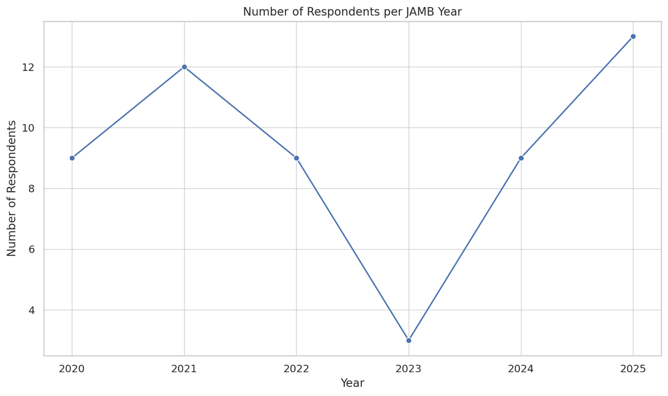

**🥧 Pie & 🍩 Donut Charts**

* **Gender Distribution Pie Chart**: Displays the male vs female distribution.
* **CBT Familiarity Donut Chart**: Shows how familiar students were with the computer-based format.

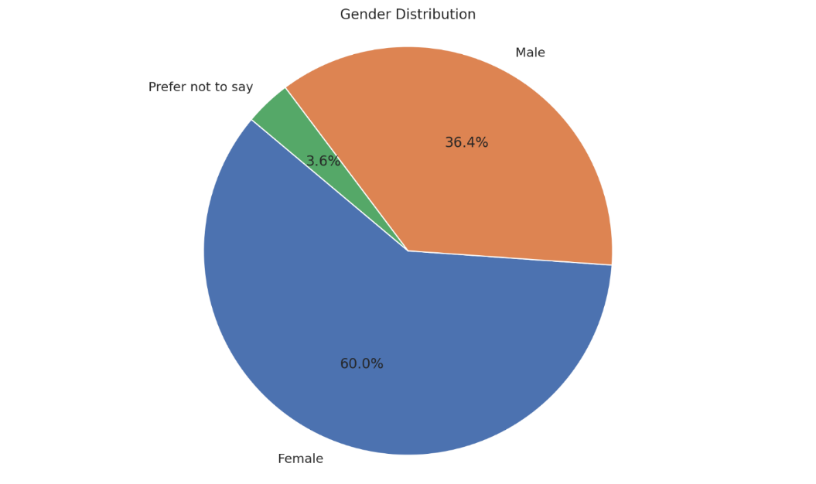

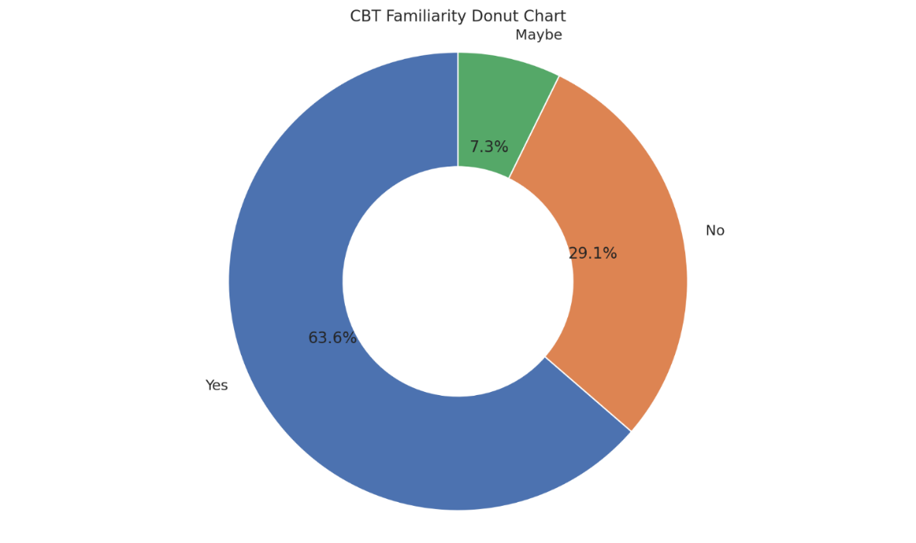

**📊 Histogram**

* **Exam Center Rating**: Distribution of ratings (1–5) for CBT center facilities.

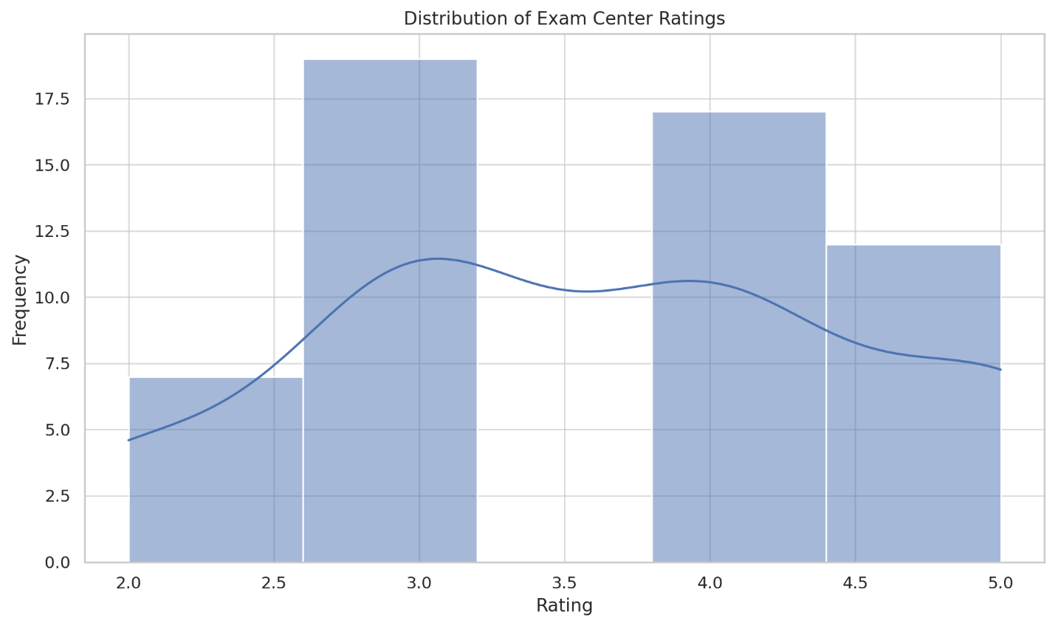

**🧮 Key Performance Indicators (KPIs)**

| **KPI** | **Value** |
| --- | --- |
| **Total Respondents** | 58 |
| **Female Respondents** | 33 |
| **Male Respondents** | 20 |
| **Average JAMB Score** | 224.91 |
| **Avg. Confidence Level** | 3.36 (out of 5) |

**THE END**